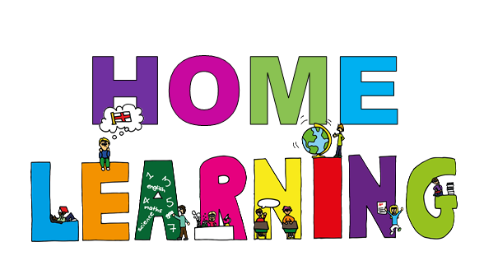

*The tasks you need to focus on are on this sheet. Handed out 20.09.24 –* ***Collected in 26.09.24****.*

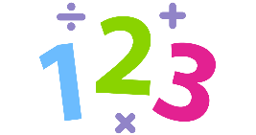

**My Spellings**

High frequency words:

1. door
2. floor
3. poor
4. gold

**Look, cover, write, check.**

**My Maths**

* Please practise the termly maths sheet



**My Reading Activity**

* Read to someone 3 times a week and talk to them about what you have read. On one of those times, you could ask someone to read a story to you!



**Parent signature _________________**

**Teacher signature _________________**