**Spelling practice 27.09.24**

*Practise the words on this list using look, say, cover, write and check.*

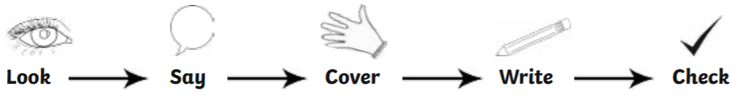

|  |  |  |  |  |
| --- | --- | --- | --- | --- |
|  | Day 1 | Day 2 | Day 3 | Day 4 |
| door |  |  |  |  |
| floor |  |  |  |  |
| poor |  |  |  |  |
| gold |  |  |  |  |

**Extra challenge: choose words from your spelling list to write phrases or sentences.**

|  |  |
| --- | --- |
| **Sentence 1** |  |
|  |
| **Sentence 2** |  |
|  |